Experiment no-16
Online Complaint Management System
Aim:
To develop a website for registering complaints and tracking their status.
Procedure:
- Create a complaint form with name, category, and description.
- Add a button to submit complaints.
- Display complaint status and confirmation.
- Run the webpage in a browser.
Sample Code:
<!DOCTYPE html>
<html>
<head><title>ComplainEase</title></head>
<body>
<h2>ComplainEase</h2>
<input id="name" placeholder="Enter Name"><br><br>
<select id="category">
<option>Service</option>
<option>Technical</option>
<option>Other</option>
</select><br><br>
<textarea id="complaint" placeholder="Enter Complaint"></textarea><br><br>
<button onclick="submitComplaint()">Submit Complaint</button>
<p id="out"></p>
<script>
function submitComplaint() {
let c = document.getElementById("complaint").value;
document.getElementById("out").innerText = c ?
"Complaint submitted successfully. Status: Pending" :
"Please enter your complaint.";
}
</script>
</body>
</html>
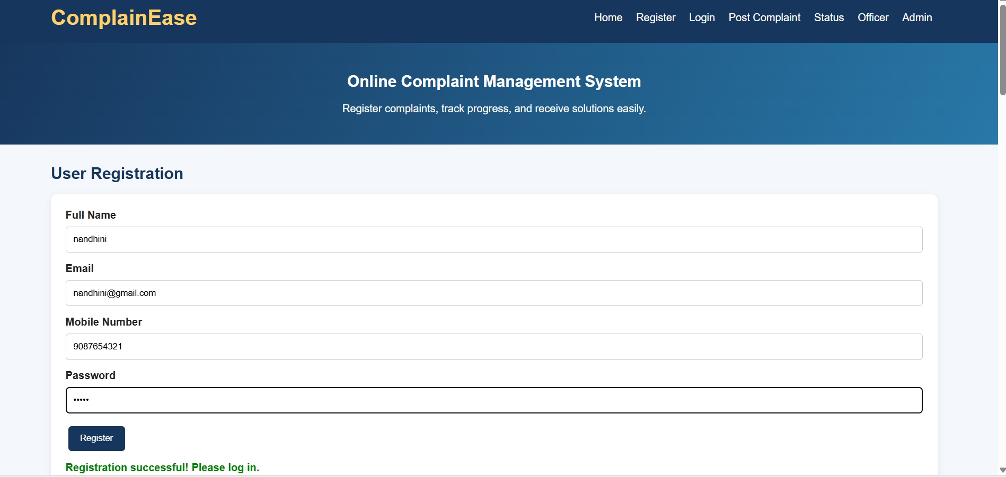
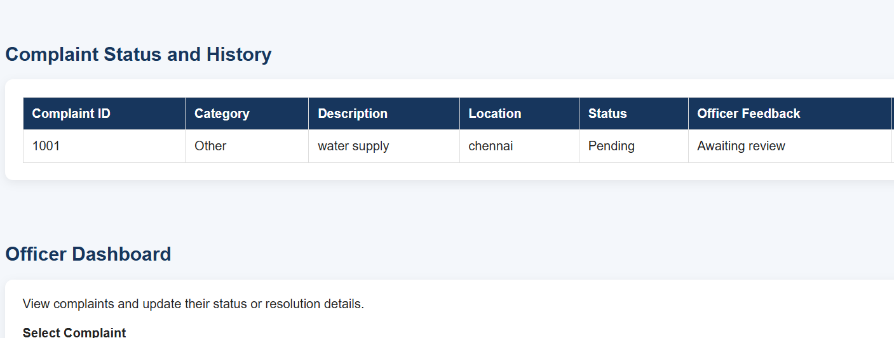
Result:
The Complain Ease webpage was created successfully with complaint submission and status display.

